Did you know that City Lit is home to an extensive collection of over 1400 music scores? We hold scores in a wide range of levels and styles, and you do not have to be on a music course to browse and borrow these.
To see what is available, enter heritage@citylit.ac.uk. If you change the media type to ‘Music score’ this will ensure you only see relevant entries.
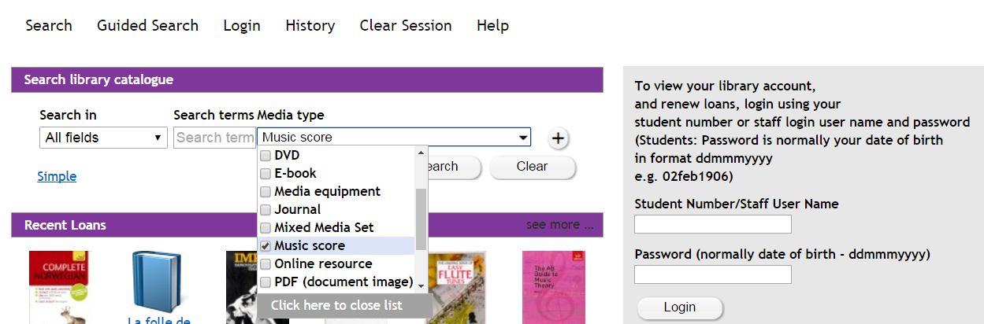

These are examples of the many search terms you can use to find scores:
- Rock, Orchestral, Classical, Pop, Jazz, Musicals, Lieder, Opera, Choral, Chamber music
- Piano, Guitar, Flute, Cello, Violin, Vocal, Percussion
- Mozart, Gershwin, Solo, Duet, Beginner, Advanced

